Nexora engagement and fundraising
Document 16 of the Nexora learning guides
Source snapshot 13 October 2026 at 17:12 UTC
Understand communities, campaigns, consented audiences, funds and donation records.

Recognise the screen and its scope
Open /engagement/communities, /engagement/campaigns, /engagement/funds. CRM routes use port 3017; member routes use 3018; public website routes can use 3019. Brackets name a route parameter, not text to paste into a browser. Choose a real record or site id from the application.
This guide covers Communities and members; Campaign drafts and prepared audiences; Consent checks; Funds; Donation recording and activity.
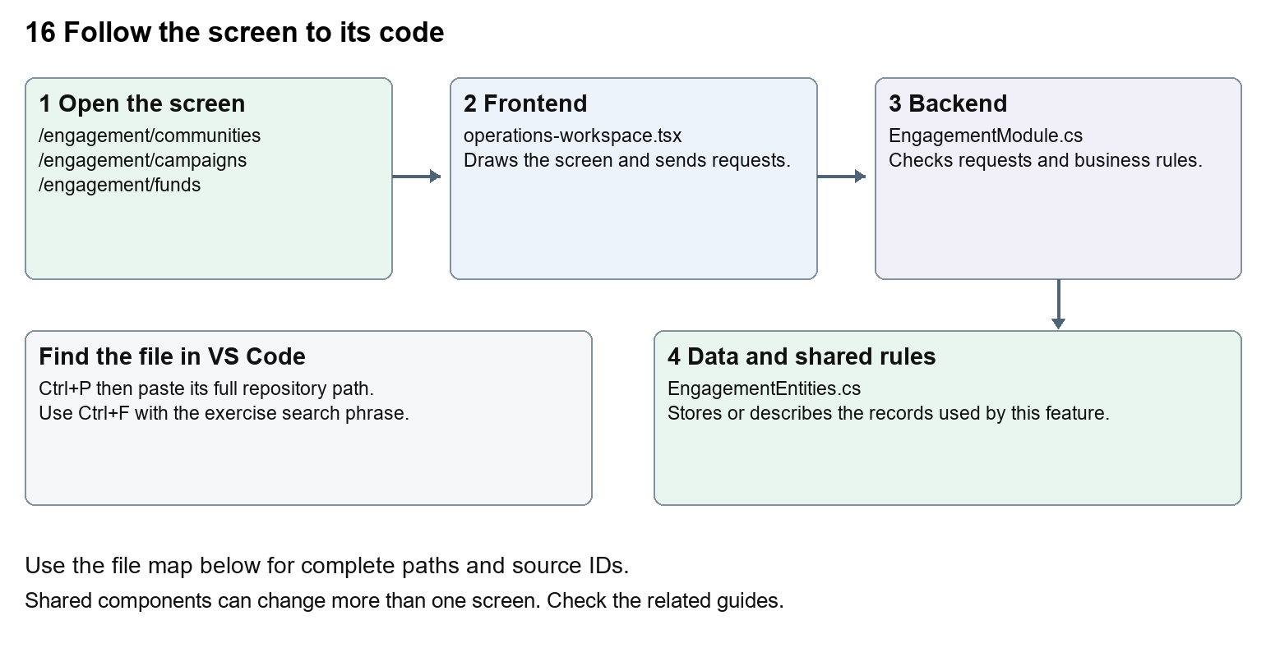
The diagram shows the file roles. The full paths below are what you paste into Ctrl+P.

Find the files in VS Code
Role | File and source ID | What it does
Screen | S0118 operations-workspace.tsx | Main UI or route for this topic
Server | S0308 EngagementModule.cs | Endpoints or server rules
Data | S0307 EngagementEntities.cs | Data shape or persistence structure

Screen S0118
apps/web/src/features/operations/operations-workspace.tsx
Server S0308
backend/src/Modules/Nexora.Modules.Engagement/EngagementModule.cs
Data S0307
backend/src/Modules/Nexora.Modules.Engagement/Domain/EngagementEntities.cs
The complete HTML manual opens these source IDs inside its Source library. The Word manual shows short labelled extracts so you can learn the flow before reading large files. Each individual Markdown guide includes its complete primary files after the walkthrough.

Follow the request and the records
1. The engagement route selects the OperationsWorkspace module and section.
2. The shared workspace loads the chosen engagement lists.
3. Forms are generated from the engagement action definitions.
4. Preparing a campaign asks the backend to build its consented audience.
5. The server persists community, campaign, fund or donation records.

Read the code with an explanation
OperationsWorkspace is shared with Work. Its engagement array describes form labels, paths and fields. A prepared audience is a set of eligible records, not evidence that emails were sent. Consent fields in CRM feed audience selection. Fundraising stores donation information without proving a banking transaction.
Source reference S0118 apps/web/src/features/operations/operations-workspace.tsx
Selected opening lines with their original numbers. The complete file is in the HTML source library.
0001 "use client";
0002 import listingStyles from "../crm/record-listing.module.css";
0003 import { WorkspaceHeading } from "@/components/ui/workspace-heading";
0004 import { RecordListing, useRecordPage } from "../shared/record-listing";
0005 import { Plus, ArrowLeft } from "lucide-react";
0006 import { useEntityListing } from "../shared/entity-listing-controls";

The import lines lead to shared components and helpers. Start at the exported component or route function; follow the request helper to the server rather than assuming the whole feature lives in this file.
Source reference S0308 backend/src/Modules/Nexora.Modules.Engagement/EngagementModule.cs
Extract from source line 28. A fragment from a long line is shown without the rest of that line.
0028 api.MapGet("/contacts",(string? search,ICrmDirectory crm,CancellationToken ct)=>crm.SearchContactsAsync(search,ct));

On the server, look for MapGet to load records, MapPost to create or perform an action, MapPut or MapPatch to change data, and RequireAuthorization for permissions. Some shared methods register endpoints indirectly. Find SaveChangesAsync to see the database write. A request method alone does not tell you every side effect.
Source reference S0307 backend/src/Modules/Nexora.Modules.Engagement/Domain/EngagementEntities.cs
Selected opening lines with their original numbers. The complete file is in the HTML source library.
0001 using Nexora.BuildingBlocks.Domain;
0002 namespace Nexora.Modules.Engagement.Domain;
0003 public sealed class Community:TenantEntity {public string Kind{get;set;}="group";public string Name{get;set;}="";public string Purpose{get;set;}="";}
0007 public sealed class CampaignRecipient:TenantEntity,IAppendOnly {public Guid CampaignId{get;set;}public Guid ContactId{get;set;}public string Email{get;set;}="";}
0008 public sealed class Fund:TenantEntity {public string Name{get;set;}="";public string Currency{get;set;}="GBP";public decimal Target{get;set;}}

Follow model fields to their request names and database mapping. An id points to a particular record. A tenant id limits the organisation. A version or concurrency stamp protects newer edits. Some model files describe contracts rather than tables; check the owning DbContext before assuming storage.

Make or trace your first change
1. Press Ctrl+P and open apps/web/src/features/operations/operations-workspace.tsx.
2. Press Ctrl+F and search for Prepare consented audience. In this snapshot it appears at line 30.
3. Change this campaign button wording only. Check the campaign detail and a Work task screen; the Work actions should be unaffected.
4. Replace only Prepare consented audience with Prepare eligible audience in that intended location. Keep quotes, tags, JSON keys and routes intact.
5. Save with Ctrl+S. Inspect Problems and the local screen. Review the diff and restore the original text when you finish practising.
Extract from source line 30. A fragment from a long line is shown without the rest of that line.
0030 e`,"POST",{version:row.version}))}>Prepare consented audience</button>}</>}{section==="notifications"&&!ro

These exercises have not been applied to the application. Their search phrases are verified against the captured source. Line numbers can move; the phrase and file path are your main navigation aids.

Check a change and diagnose problems
Confirm the original screen still loads, the changed words appear in the intended place, and another screen using the same component still behaves correctly. If an action fails, inspect the browser Network response, the relevant helper and server validation message. Use the common error table at the beginning of the manual. Reload on a version conflict instead of removing the version check.
A syntax error after a text edit usually means a quote, brace or closing tag changed. Compare your diff with the original. An unchanged browser result can mean the wrong port, a saved published configuration overriding a default, or a running API that has not reloaded.

Understand the current limits
Campaign audience preparation does not connect an email delivery provider. A donation record does not charge a donor. Consent and suppression checks remain server-side business rules.

Continue learning
Related guides 05 Nexora CRM contacts, 15 Nexora sales and finance, 17 Nexora tasks and notifications.

